**Lab 4:**

**Operational Amplifiers – Part II**

Name: Wan-Yu Liao

ECEN 325 Section 514

TA: Mandela

Lab Date: September 27, 2019

Lab Report Due Date: September 30, 2019

**Calculations**

(1)



(2)



(3)



(4)



**Simulations**

**Circuit 1 (Summing Amplifier):**

(a)

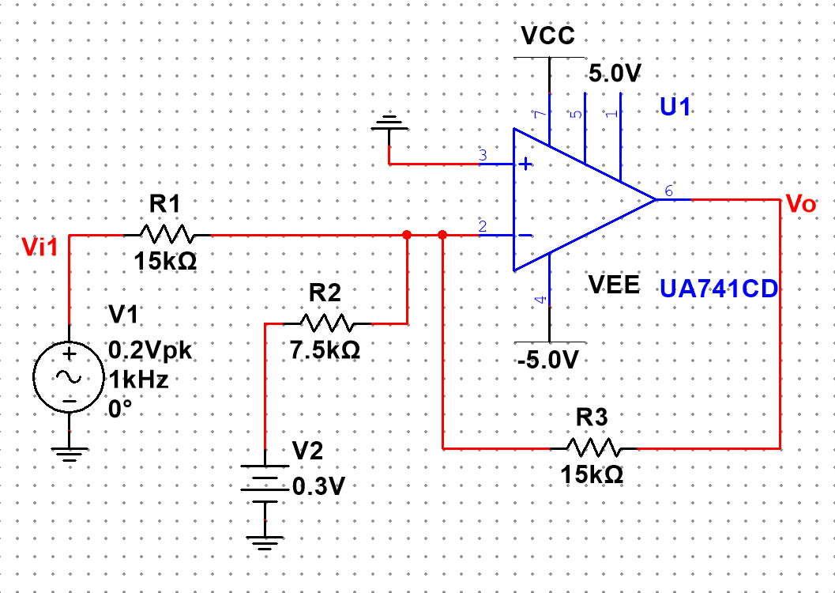

(b)

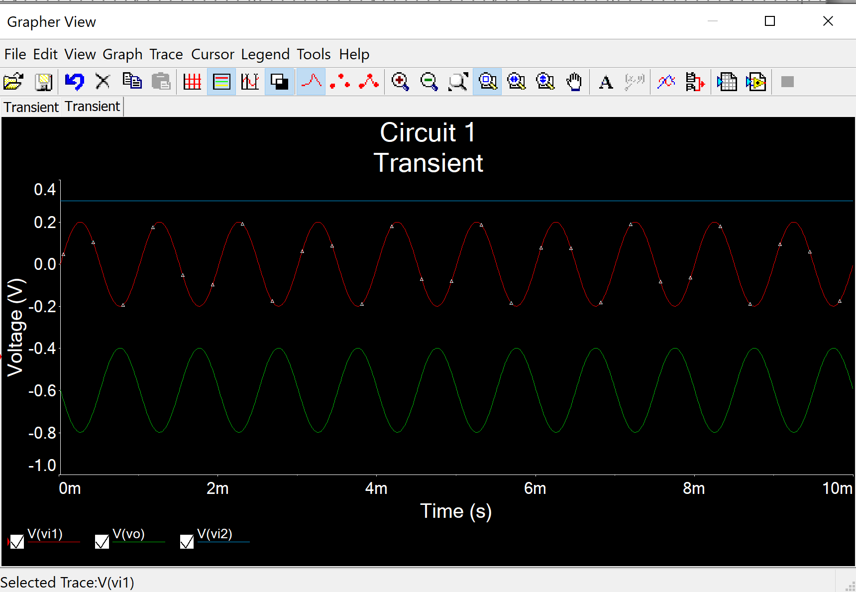

, which is opposite the Vi1 and shift down by 0.6.

**Circuit 2 (Differential Amplifier):**

(a)

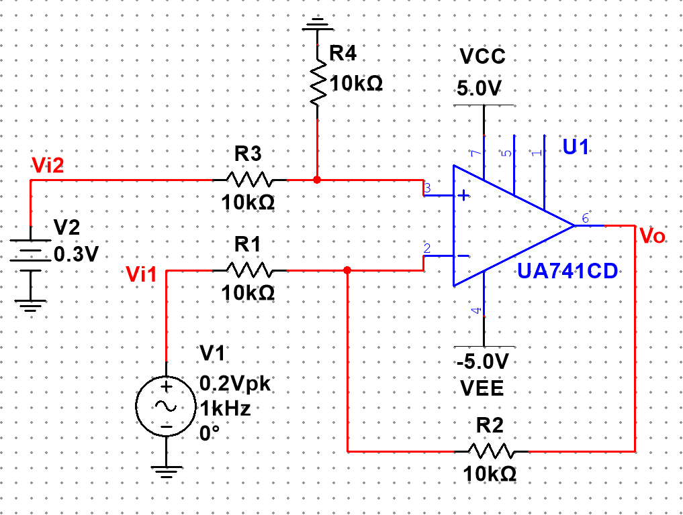

(b)

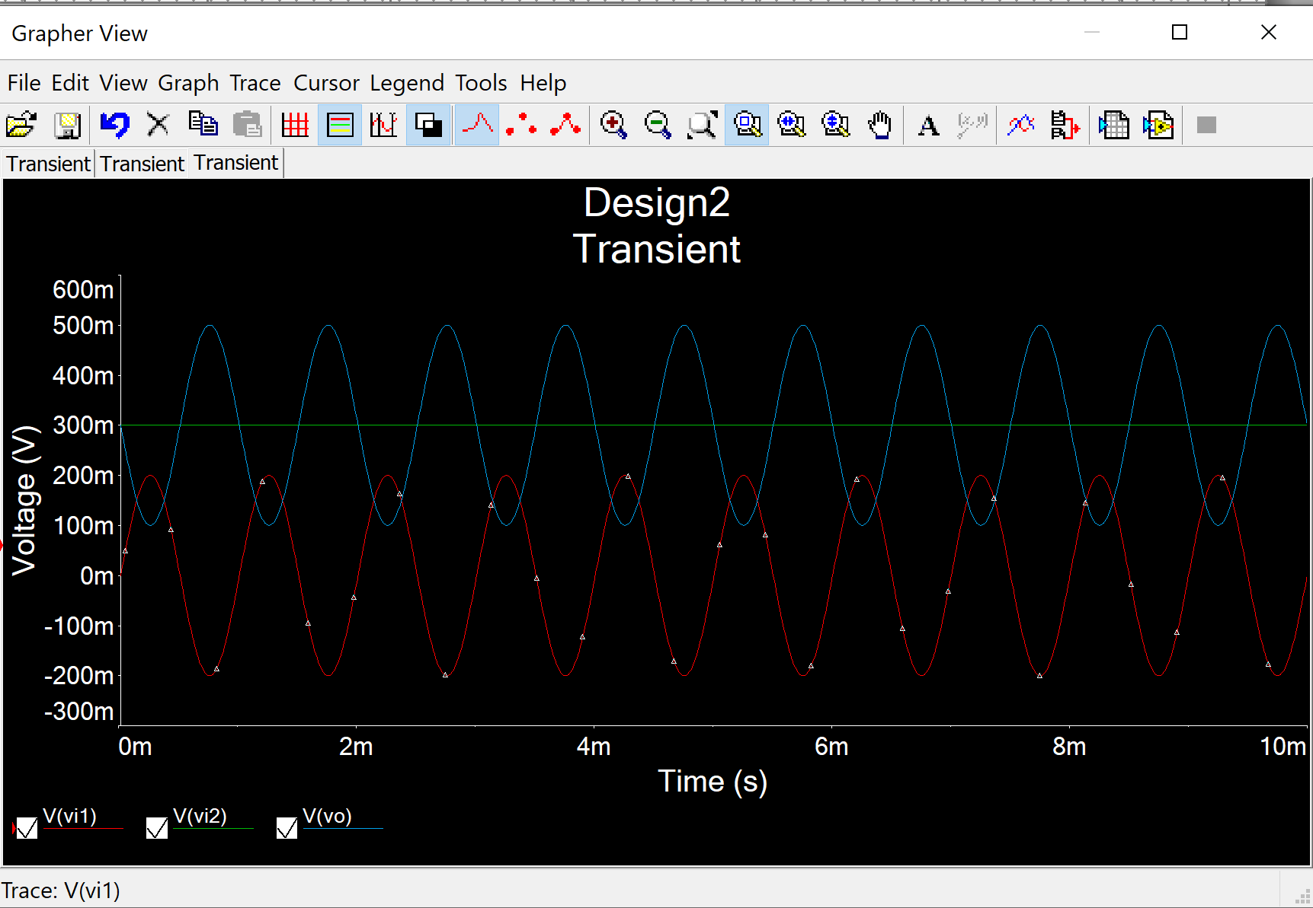

, which is opposite the Vi1 and shift up by 0.3.

**Circuit 3 (Instrumentation Amplifier):**

(a)

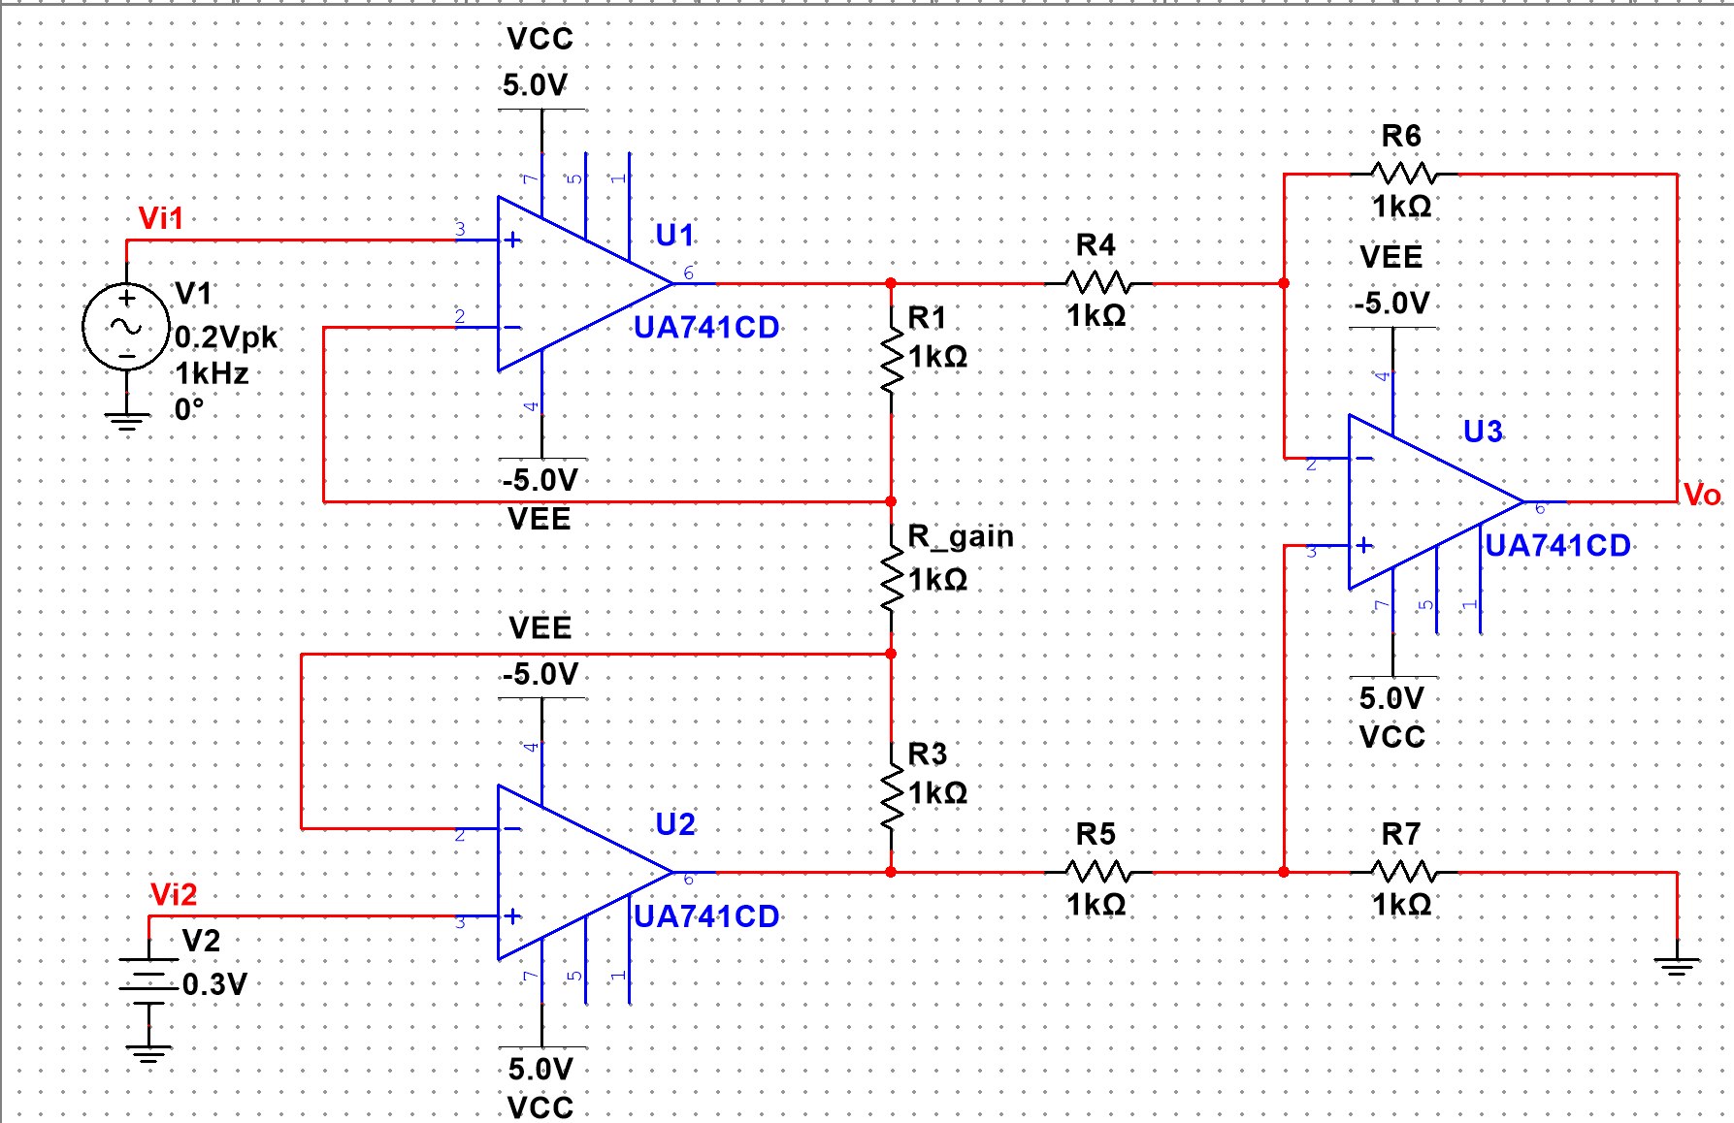

(b)

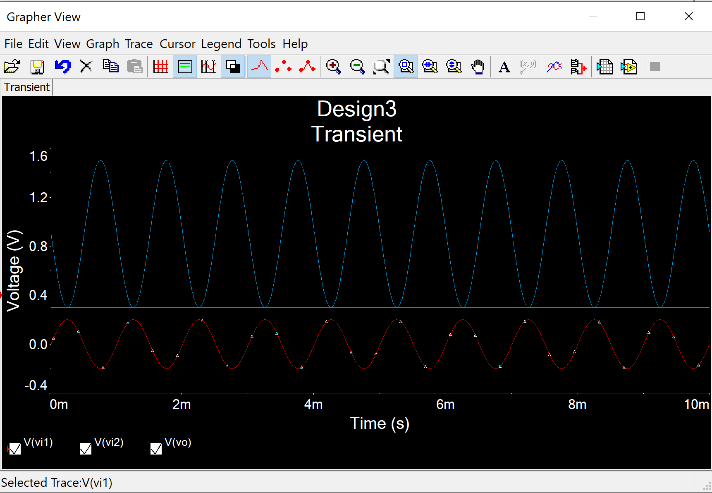

which is opposite the Vi1 with amplitude of 0.6 and shift up by 0.9.

**Measurements**

**Circuit 1 (Summing Amplifier):**

**Time-Domain Waveform**

Vo (C2) shifted down 0.6 and is opposite to V1 (C1).

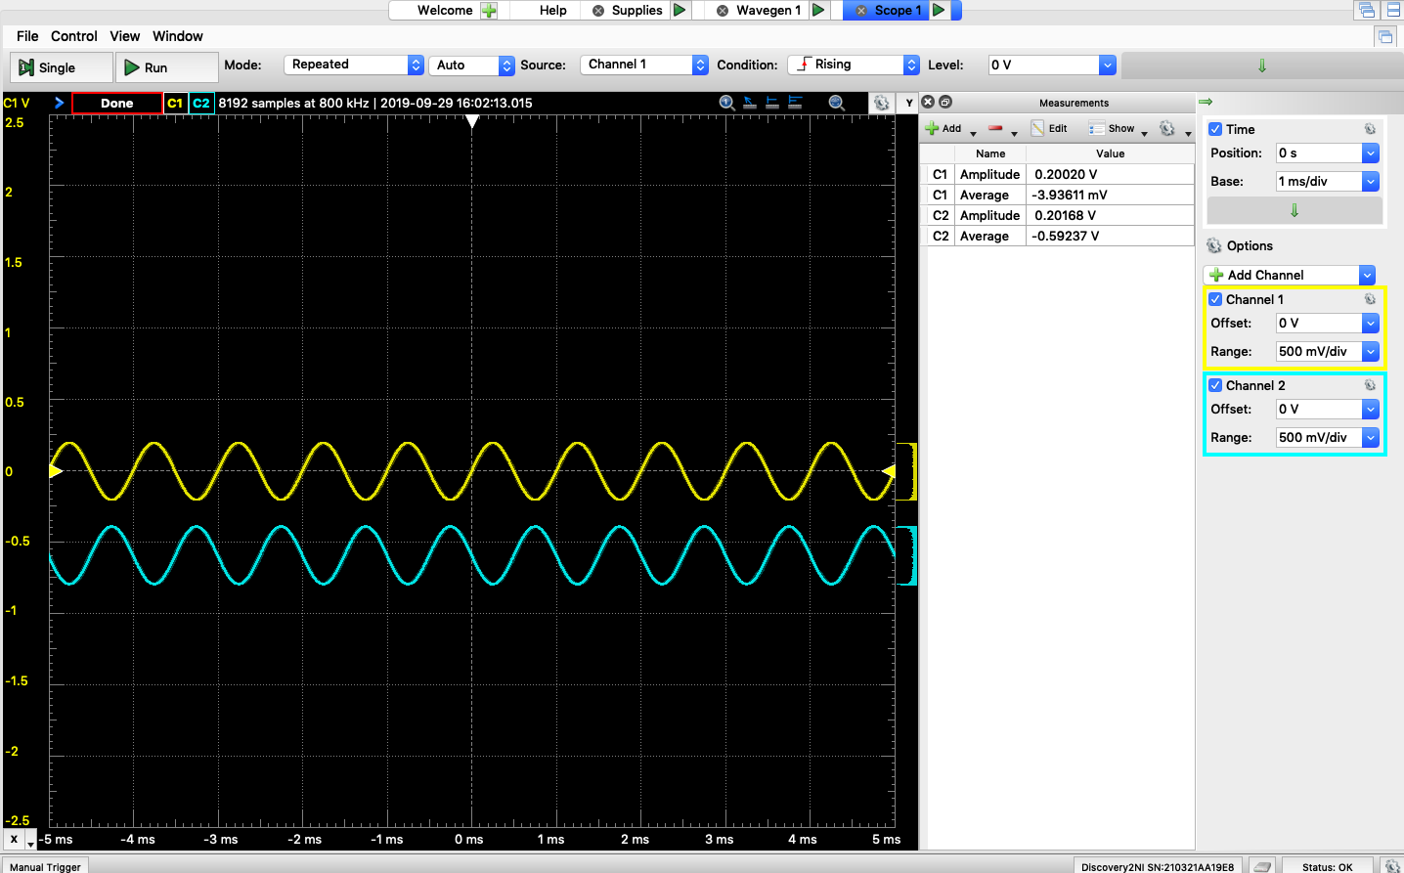

**Clipping Waveform Generator**

V2 = 1.5V

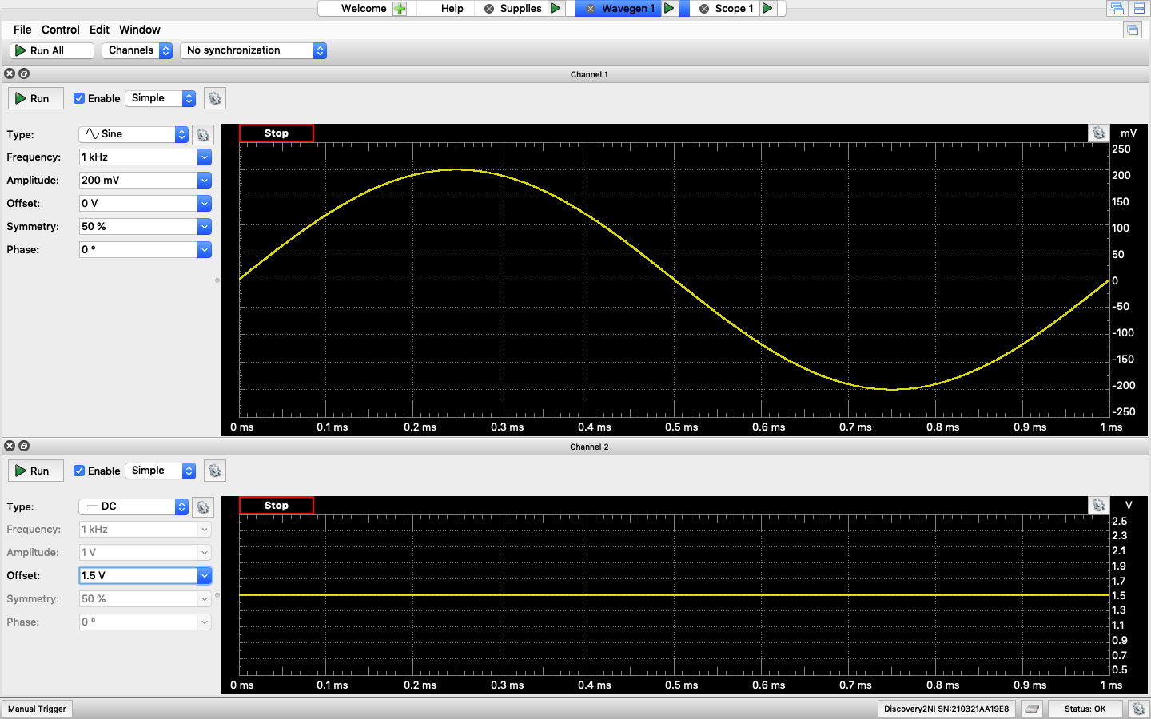

**Clipping Time-Domain Waveform**

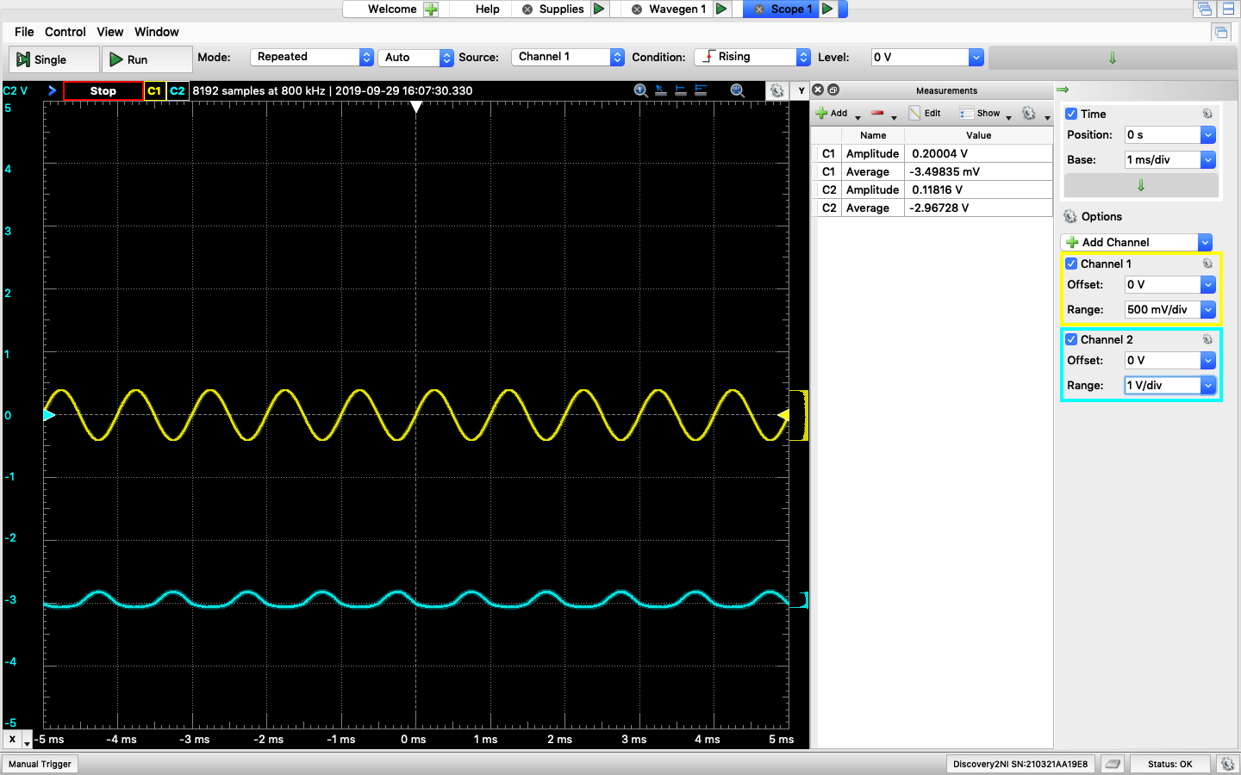

**Circuit 2 (Differential Amplifier):**

**Time-Domain Waveform**

Vo (C1) shifted up 0.3 and opposite to V1 (C2).

**DM**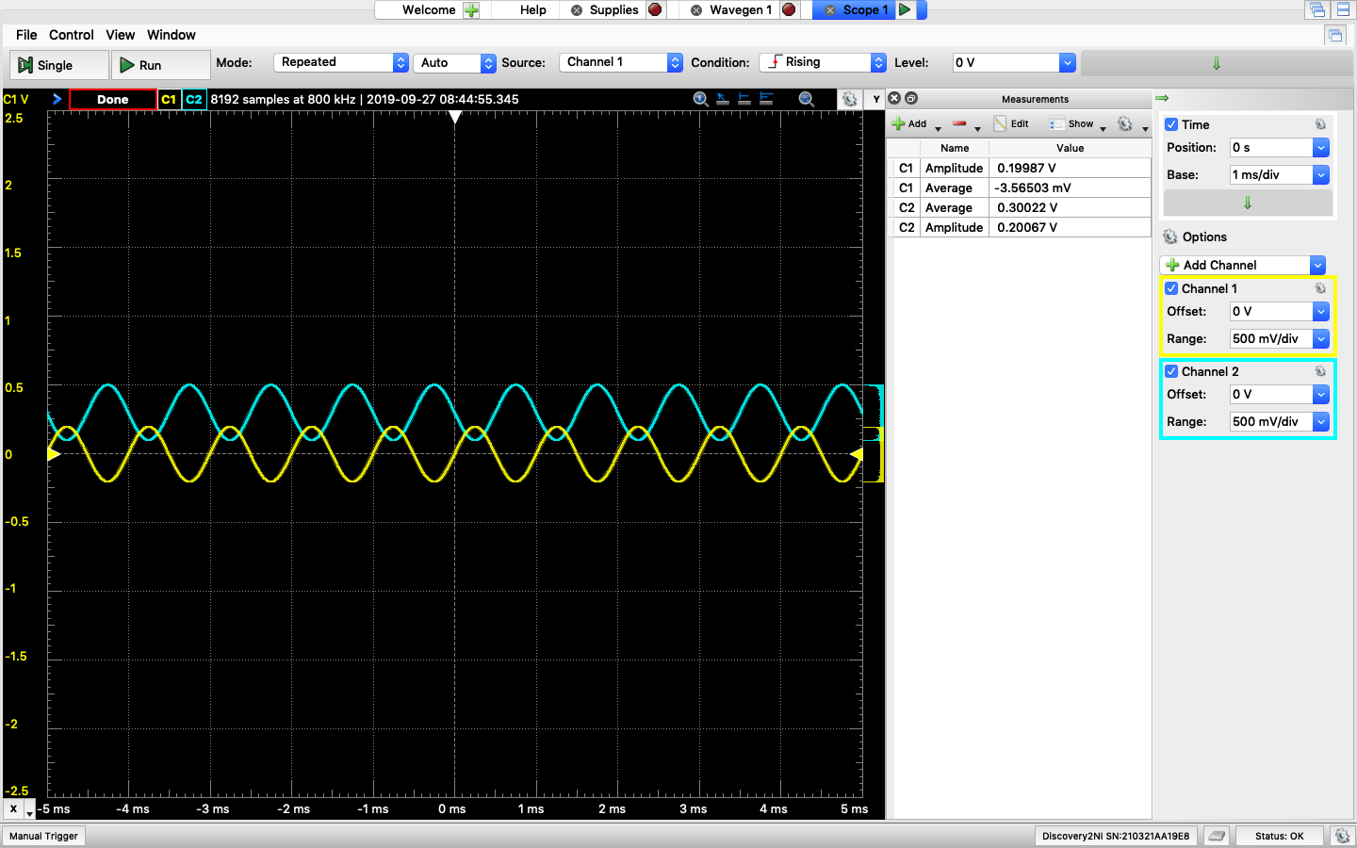

**ADM Time-Domain Waveform**

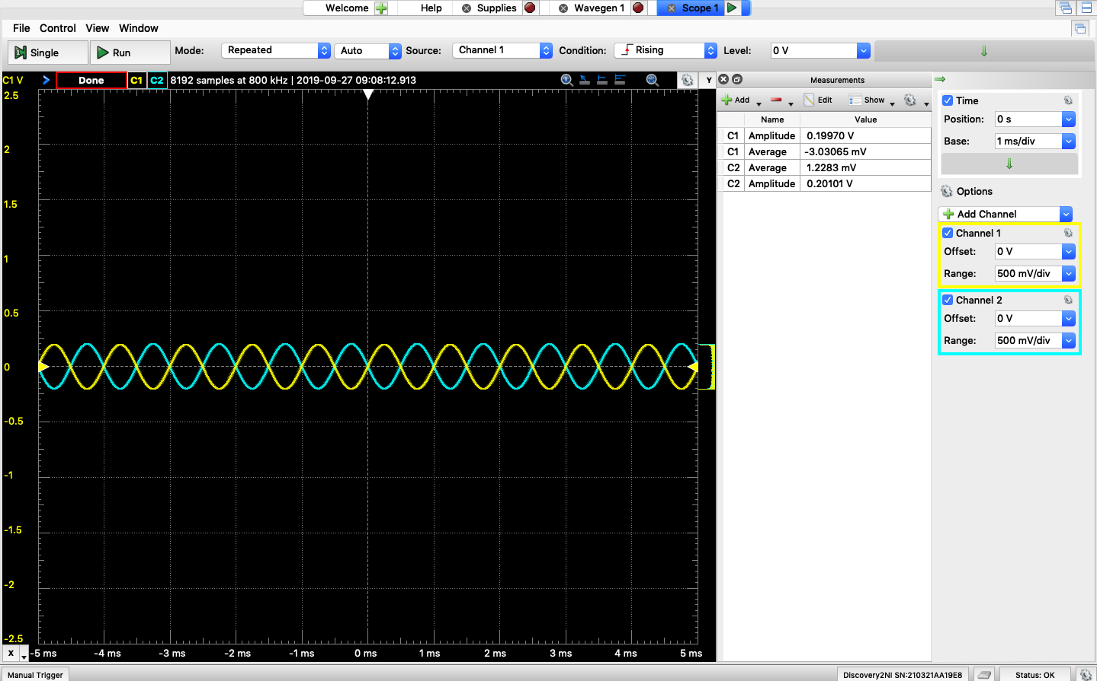

**ACM Time-Domain Waveform**

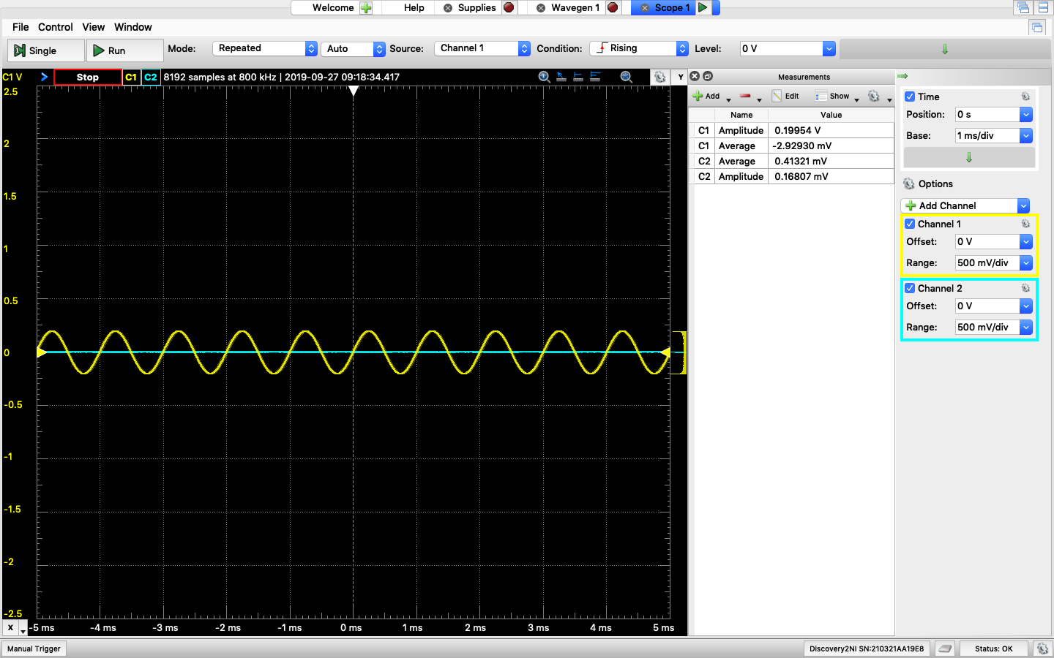

**Circuit 3 (Instrumentation Amplifier):**

**Time-Domain Waveform**

Vo (C2) shifted up 0.9 and is opposite to V1 (C1) and the amplitude increase to 0.6.

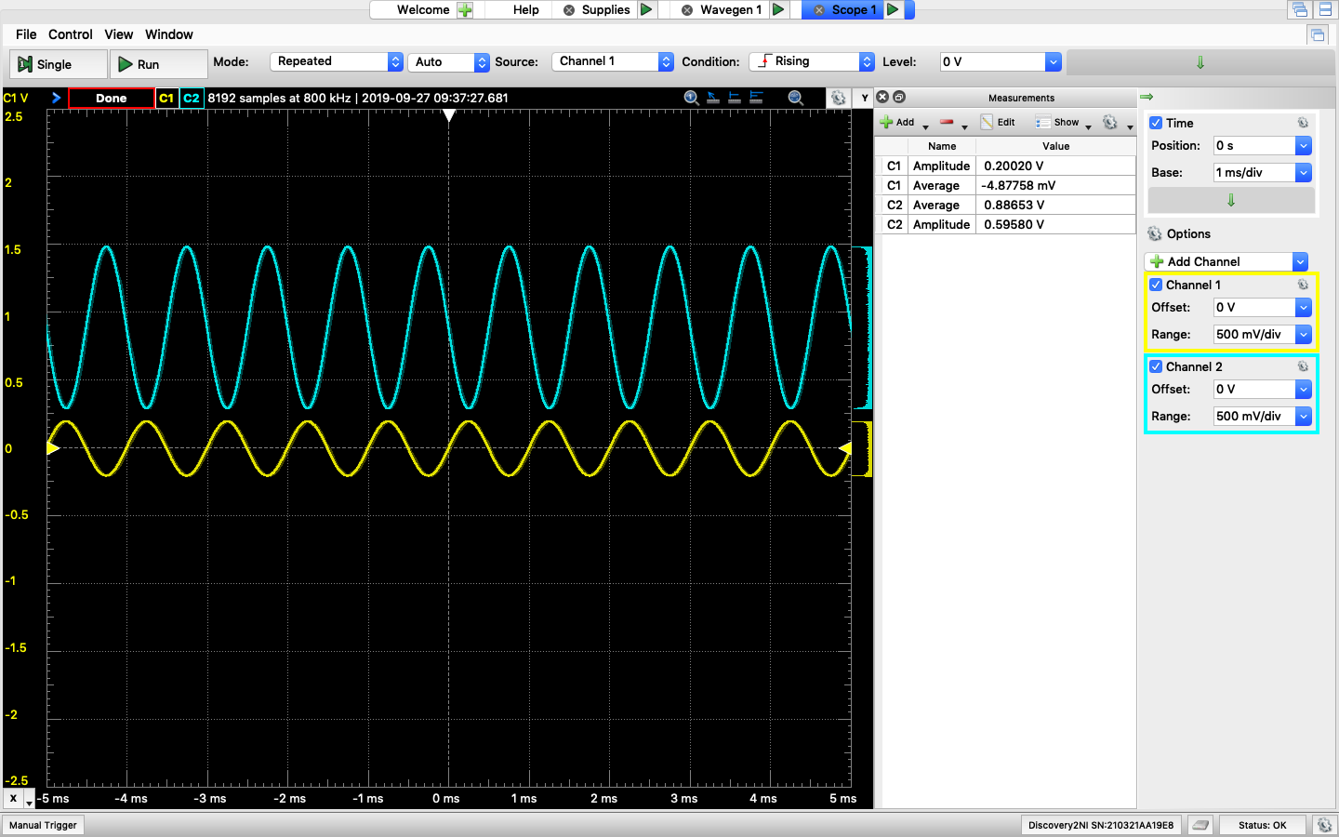

**Saturated Point for UA741 (Extra Question):**

Positive Vsat = 4.381V

Negative Vsat = -3.129V

**Tables**

|  |  |  |  |
| --- | --- | --- | --- |
|  | Amplitude | Average | Opposite to V1 |
| Circuit 1 Calculated | 0.2 | -0.6 | Yes |
| Circuit 1 Simulated | 0.2 | -0.6 | Yes |
| Circuit 1 Measurement | 0.202 | -0.592 | Yes |
| Circuit 2 Calculated | 0.2 | 0.3 | Yes |
| Circuit 2 Simulated | 0.2 | 0.3 | Yes |
| Circuit 2 Measurement | 0.201 | 0.300 | Yes |
| Circuit 3 Calculated | 0.6 | 0.9 | Yes |
| Circuit 3 Simulated | 0.6 | 0.9 | Yes |
| Circuit 3 Measurement | 0.596 | 0.886 | Yes |

**Comments**

The results from calculated part, simulated part, and measurement part are similar. The slightly different for measurement results are due to the real-world amplifiers and resistors have some tolerance.

CMRR value calculated in Circuit 2 Measurement part is 1190.76. The ideal CMRR value supposed to be infinity, ADM supposed to be 1, and ACM supposed to be 0. However, in real-world, ADM can only be close to 1, and ACM can only be close to 0. Therefore, CMRR value cannot be infinity but it would be a large value.